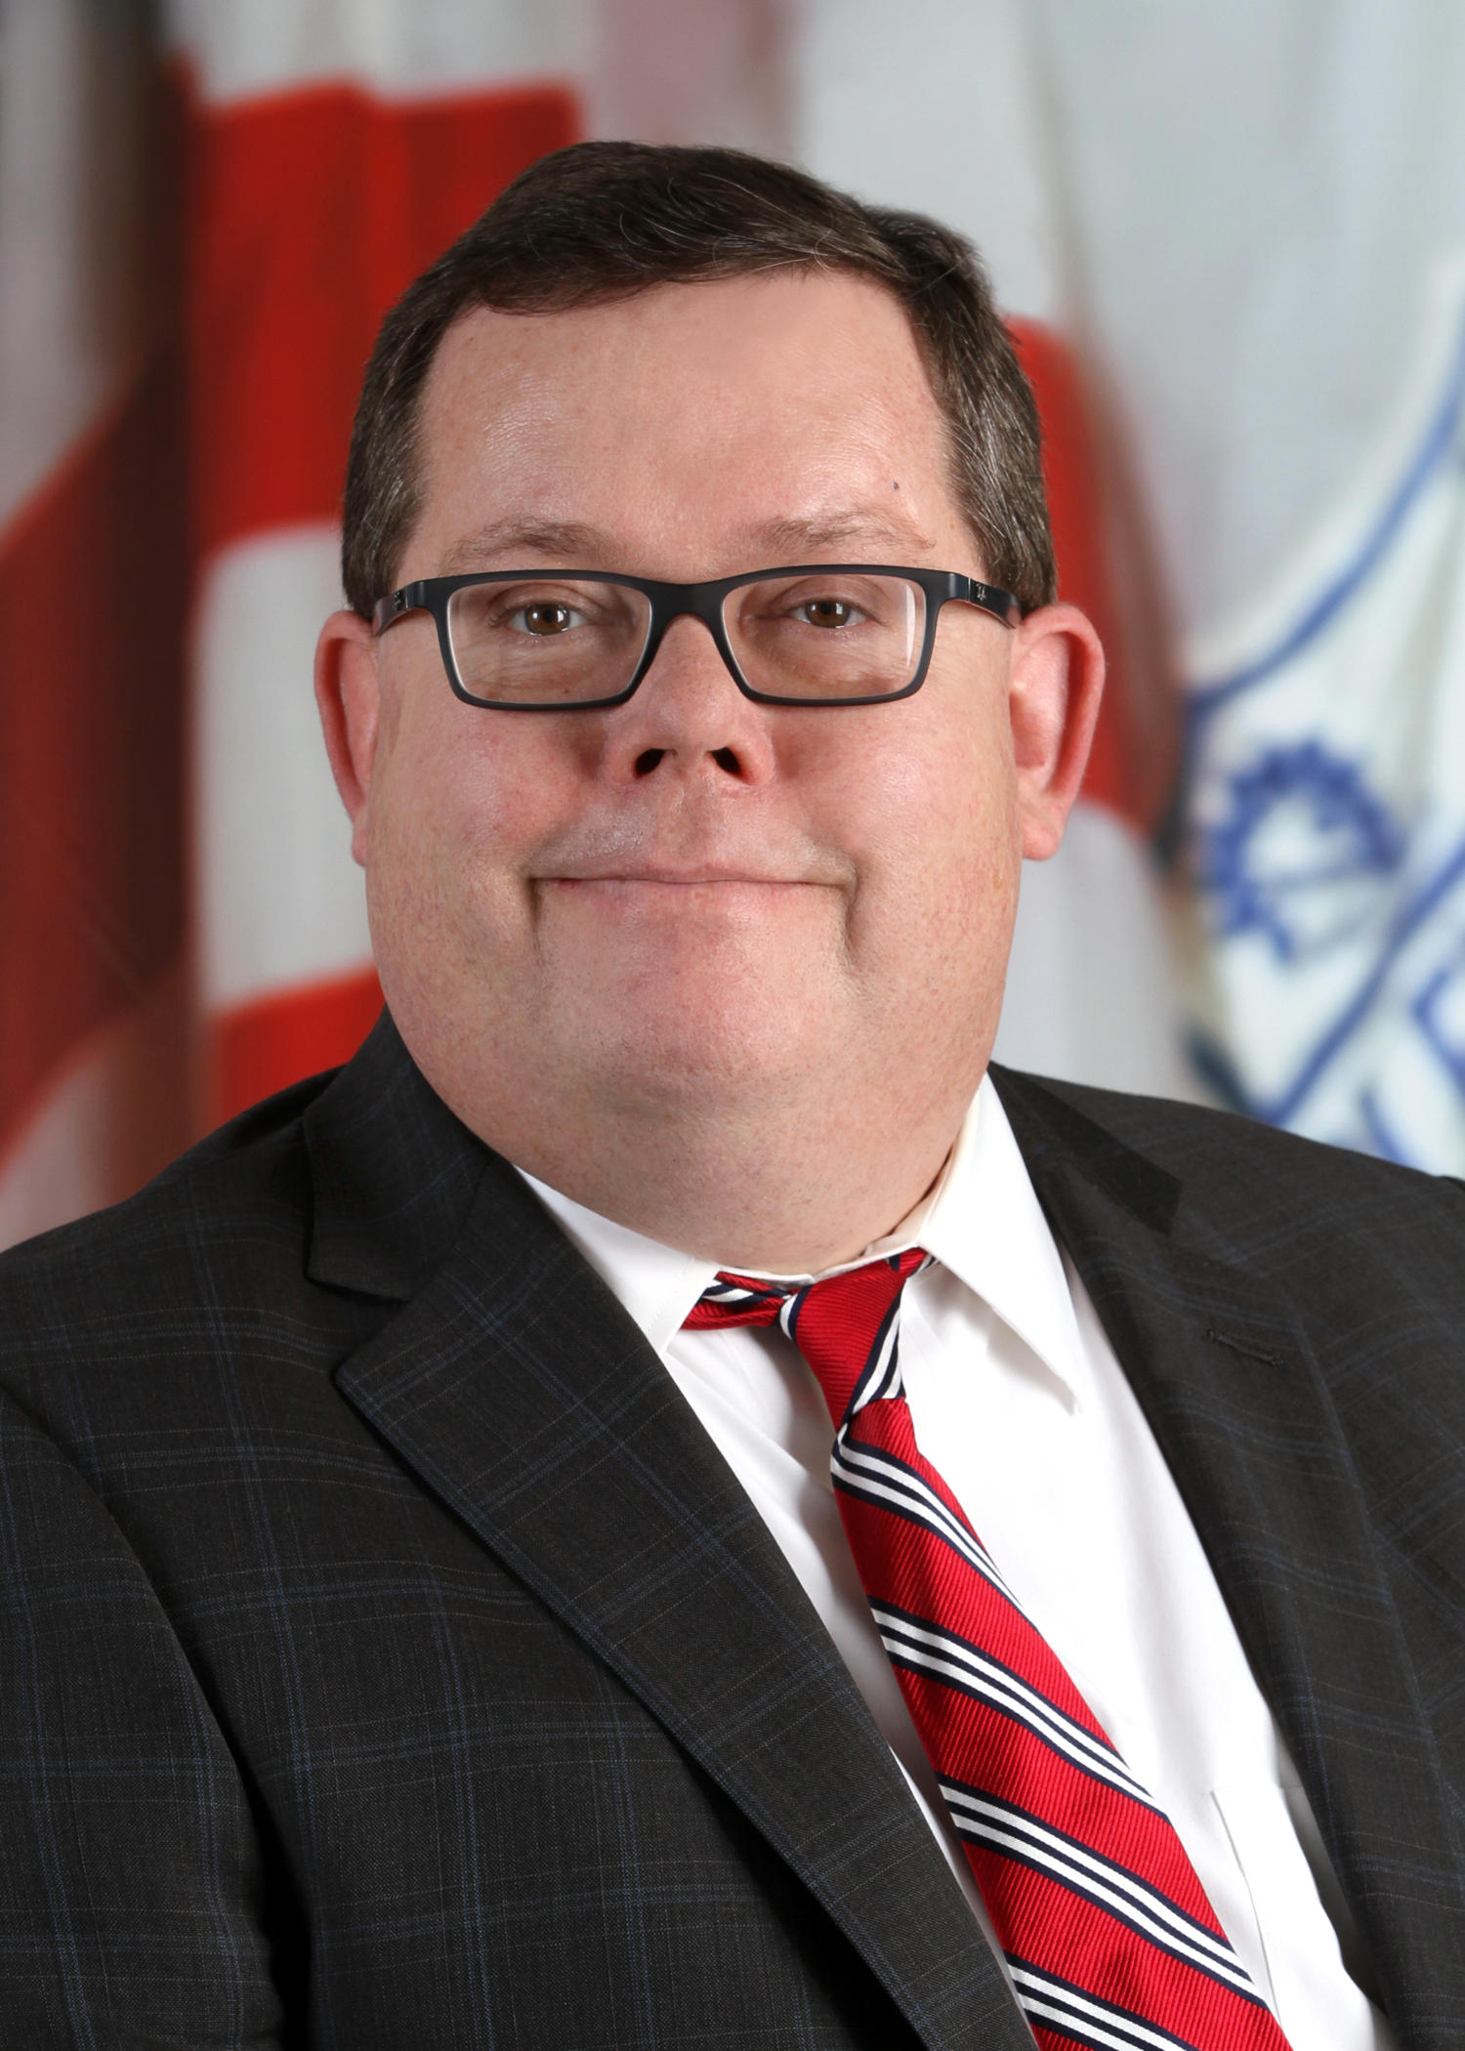
Councilman Brian Mooney was appointed in February 2020 to represent Ward 11 which includes parts of Edgewater, Cudell, West Boulevard, Jefferson and Bellaire-Puritas neighborhoods. He replaces Dona Brady who resigned her position.

Councilman Mooney serves on council’s Finance, Municipal Services & Properties, Workforce & Community Benefits, and Mayor’s Appointments committees.

He is a lawyer who has held many public positions, including assistant county prosecutor for Cuyahoga County, a volunteer magistrate for Cuyahoga County Juvenile Court, a mediator for the Cleveland City Prosecutor’s office, and an assistant Ohio attorney general in the agency’s charitable law section.

Councilman Mooney will be finishing out Councilwoman Brady’s current term which expires January 1, 2022. He will have to run for election in November 2021 for a full term, which is four years.

He graduated from St. Ignatius High School in 1987. He earned a bachelor’s degree from American University in Washington D.C. in 1992 and a juris doctor degree from Cleveland Marshall College of Law in 1995.

